[11:00-11:35] Continuation of Lecture 1: Sampling and sound in MATLAB
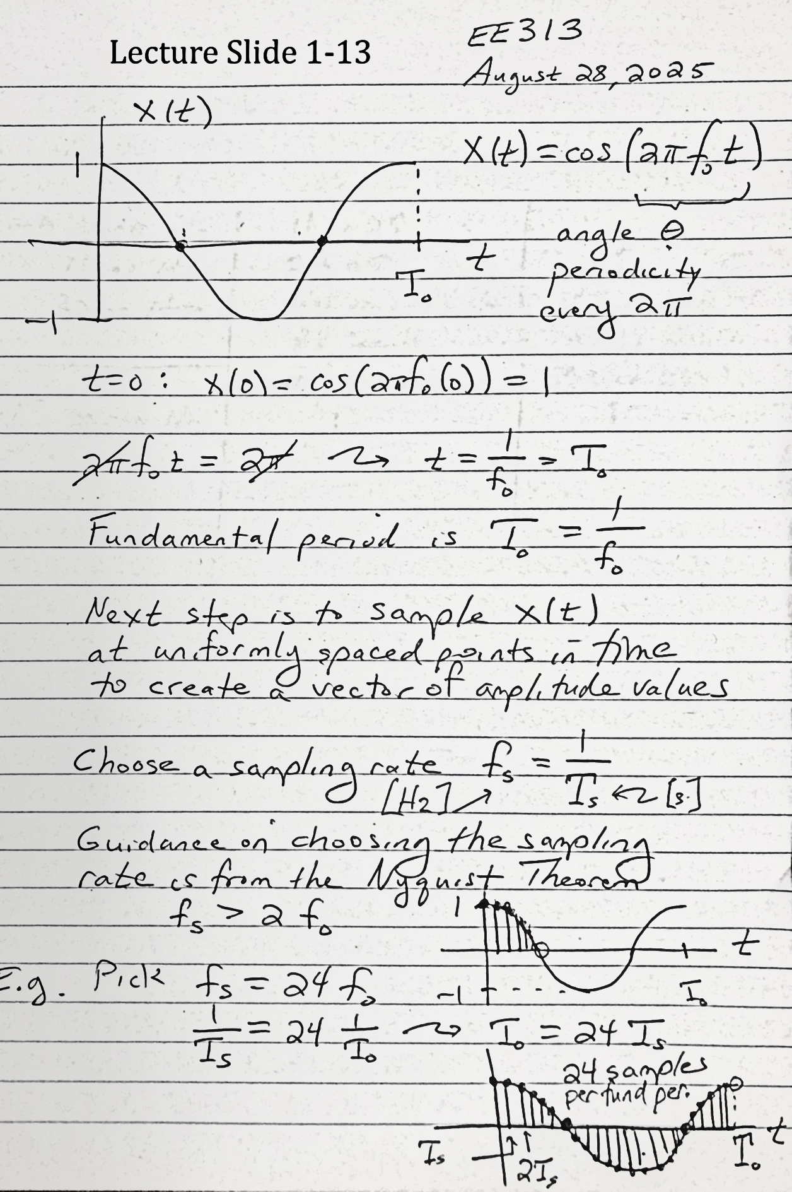
To reconstruct a frequency $f$, a signal must be sampled at a rate strictly greater than $2f$.
It’s common to sample much higher than $2f$. Audio is often sampled at 48,000 Hz or higher, even though the maximum audible frequency is between 15,000 Hz and 17,000 Hz for most adults.
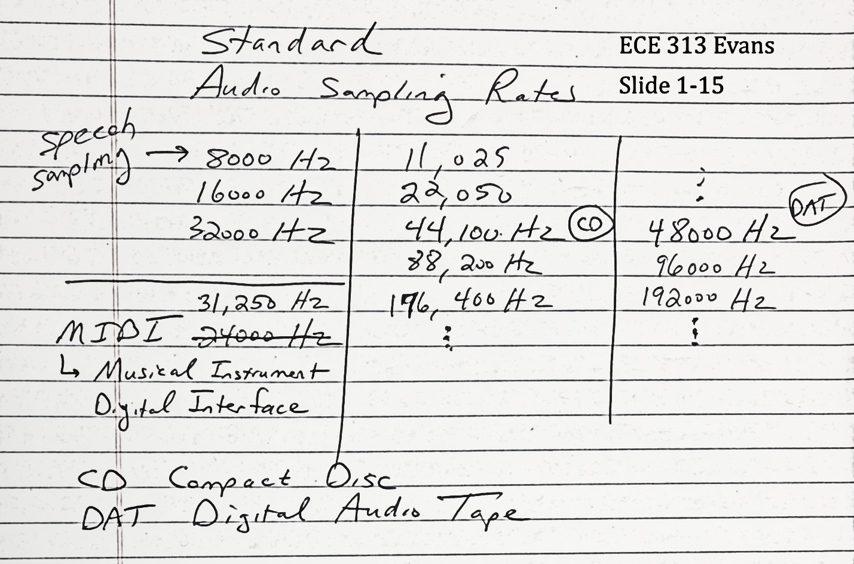
MATLAB’s sound(x) command will play an audio signal represented by an array x using the default sample rate of 8192 Hz. A different sampling rate fs can be specified using sound(x,fs), in which case MATLAB will automatically resample the sound to a rate that is compatible with the computer’s sound system.
The soundsc command will scale the range of the signal to [-1, 1] prior to playing it. This increases the volume of small amplitude signals and prevents clipping when playing a signal whose amplitude exceeds the range [-1,1].
[11:35 – 12:05] Systems
Systems operate on one or more input signals to produce one or more output signals.
Examples:

Averaging a continuoussignal with a one-second delayed version of itself:
$$y\left(t\right)=\frac{1}{2}x\left(t\right)+\frac{1}{2}x(t-1)$$
Discrete time low-pass averaging filter:
$$y\left[n\right]=\frac{1}{2}x\left[n\right]+\frac{1}{2}x[n-1]$$
Squaring block:
$$y\left(t\right)=x{\left(t\right)}^{2}$$
The squaring block is nonlinear and changes the frequency or frequencies of the input signal $x(t)$. The output $y\left(t\right)$ of the squaring block contains:
- Double the frequency (or frequencies) of $x(t)$
- A DC offset (zero Hertz)

[11:55-12:05] Lecture 2: Periodic signals
A signal $x\left(t\right)$ is periodic with period $T$ if $x\left(t-nT\right)=x(t)$ for any integer $n$.
A periodic signal can have multiple periods. The smallest positive period is the fundamental period.
Time shift and phase shift
A common system involves shifting a signal $x\left(t\right)$ in time by $T$ seconds. If $T$ is positive, this system is also called a delay.
$$D_{T}\{x(t)\}=x(t-T)$$
For sinusoids, a time shift causes a phase shift:
$$D_{T}\left\{A\cos\left(2πf_{0}t\right)\right\}=A\cos\left(2πf_{0}(t-T)\right)=A\cos\left(2πf_{0}t-2πf_{0}T\right)$$
Phase shifts are commonly used in wireless communications, sonar, and radar systems to separate signals spatially.

